Market Research & Specifications
- Apple MacBook Air (M3)

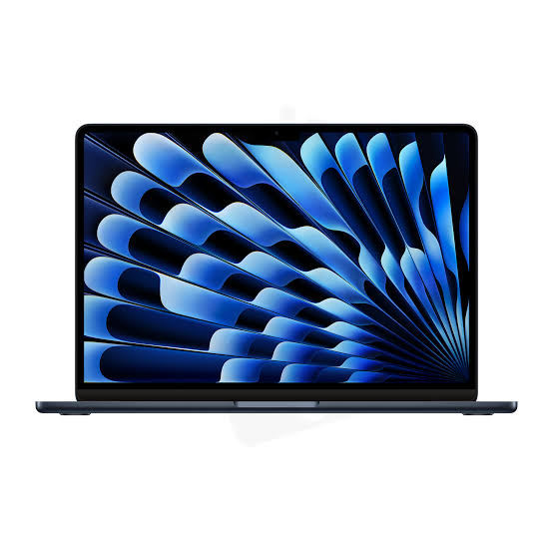
- Category: Best Overall Ultrabook
- Global User Rating: ⭐ 4.8 out of 5
- Key Specs: Apple M3 Chip (8-Core CPU/8-Core GPU), 8GB/16GB Unified Memory, Liquid Retina Display.
- Global Price: $1,099 - $1,299
- Estimated LKR Price: LKR 330,000 - LKR 390,000
- Target Audience: Higher-education students, remote executives, and developers demanding silent operation and extensive battery life (up to 18 hours).
- Official Product Link: Apple MacBook Air Official Store

- Dell XPS 13 Plus
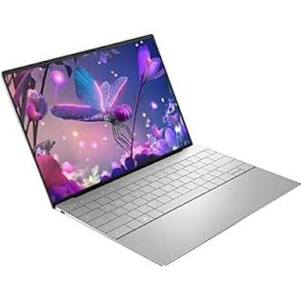

- Category: Premium Windows Ultrabook
- Global User Rating: ⭐ 4.3 out of 5
- Key Specs: Intel Core Ultra 7, InfinityEdge 13.4" 3.5K OLED Touch Display, Seamless Glass Haptic Touchpad.
- Global Price: $1,200 - $1,500
- Estimated LKR Price: LKR 360,000 - LKR 450,000
- Target Audience: Corporate executives and design minimalists who value cutting-edge aesthetics and screen clarity.
- Official Product Link: Dell XPS Official Store

- HP Spectre x360 14
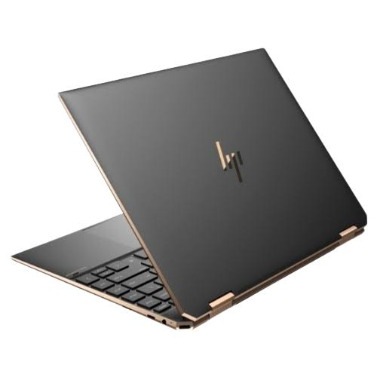
- Category: Best 2-in-1 Convertible
- Global User Rating: ⭐ 4.6 out of 5
- Key Specs: Intel Core Ultra 7, 16GB/32GB RAM, 14" 2.8K OLED Touchscreen with a 360-degree variable hinge.
- Global Price: $1,400 - $1,650
- Estimated LKR Price: LKR 420,000 - LKR 495,000
- Target Audience: Digital illustrators, architectural draftspersons, and creative directors needing tablet versatility with a precision stylus.
- Official Product Link: HP Spectre Official Store

- Lenovo ThinkPad X1 Carbon (Gen 12)
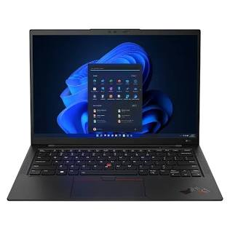
- Category: Best Enterprise Business Laptop
- Global User Rating: ⭐ 4.5 out of 5
- Key Specs: Intel Core Ultra 7, Lightweight Carbon Fiber Chassis, Ergonomic Spill-Resistant Keyboard, MIL-SPEC Durability.
- Global Price: $1,600 - $1,900
- Estimated LKR Price: LKR 480,000 - LKR 570,000
- Target Audience: Systems engineers, corporate lawyers, and enterprise-level traveling consultants requiring military-grade chassis resilience and data security.
- Official Product Link: Lenovo ThinkPad X1 Carbon Official Store

- ASUS ROG Zephyrus G14
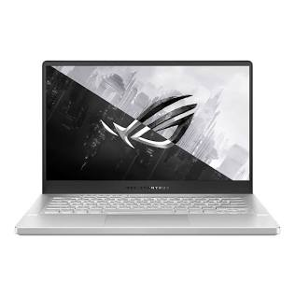
- Category: Best Compact Gaming & Creator Laptop
- Global User Rating: ⭐ 4.5 out of 5
- Key Specs: AMD Ryzen 9, NVIDIA RTX 4060/4070 Dedicated GPU, 14" ROG Nebula 120Hz OLED Display.
- Global Price: $1,400 - $1,750
- Estimated LKR Price: LKR 420,000 - LKR 525,000
- Target Audience: 3D modelers, hardcore gamers, and 4K video editors requiring top-tier computing power in a lightweight 14-inch footprint.
- Official Product Link: ASUS ROG Zephyrus G14 Official Store

- Acer Swift Go 14
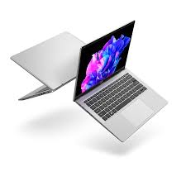
- Category: Best Value OLED Entry
- Global User Rating: ⭐ 4.4 out of 5
- Key Specs: Intel Core Ultra 5 / AMD Ryzen 5, 14" 90Hz OLED Panel, Thin-Bezel Aluminum Frame.
- Global Price: $650 - $800
- Estimated LKR Price: LKR 195,000 - LKR 240,000
- Target Audience: Freelancers, content writers, and university students seeking high-quality display tech without paying flagship prices.
- Official Product Link: Acer Swift Go Official Store

- Apple MacBook Pro 14" (M3 Pro)
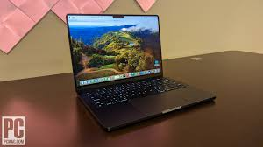
- Category: Ultimate Professional Workstation
- Global User Rating: ⭐ 4.9 out of 5
- Key Specs: Apple M3 Pro Chip, up to 36GB Unified Memory, Liquid Retina XDR ProMotion Display.
- Global Price: $1,999 - $2,399
- Estimated LKR Price: LKR 600,000 - LKR 720,000
- Target Audience: Professional colorists, full-stack software architects, data scientists compiling local machine learning code, and studio photographers.
- Official Product Link: Apple MacBook Pro Official Store
- Microsoft Surface Laptop 7
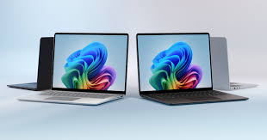
- Category: Best Next-Gen ARM AI Laptop (Copilot+)
- Global User Rating: ⭐ 4.6 out of 5
- Key Specs: Snapdragon X Elite Processor, PixelSense Touchscreen, Dedicated NPU (Neural Processing Unit).
- Global Price: $999 - $1,299
- Estimated LKR Price: LKR 300,000 - LKR 390,000
- Target Audience: Tech early-adopters wanting Mac-level thermal efficiency and real-time AI productivity tools inside a native Windows interface.
- Official Product Link: Microsoft Surface Official Store
- Lenovo Yoga Pro 9i
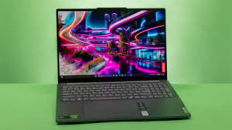
- Category: Premium Large-Format Creator Laptop
- Global User Rating: ⭐ 4.5 out of 5
- Key Specs: Intel Core i9 (14th Gen), NVIDIA RTX 4070, 16" Mini-LED High-Brightness Display.
- Global Price: $1,700 - $2,000
- Estimated LKR Price: LKR 510,000 - LKR 600,000
- Target Audience: Studio-based UI/UX designers, broadcast video editors, and Windows power-users looking for a direct alternative to the 16-inch MacBook Pro.
- Official Product Link: Lenovo Yoga Series Official Store
- ASUS Zenbook 14 OLED
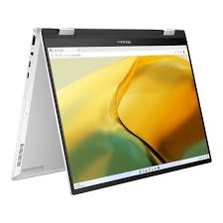
- Category: Best Mid-Range Daily Driver
- Global User Rating: ⭐ 4.6 out of 5
- Key Specs: Intel Core Ultra 7, 16GB LPDDR5X RAM, 1TB NVMe SSD, 14" 3K OLED Display.
- Global Price: $900 - $1,050
- Estimated LKR Price: LKR 270,000 - LKR 315,000
- Target Audience: Mid-level software engineers, office administrators, and general consumers seeking a balance of luxury and performance.
- Official Product Link: ASUS Zenbook Official Store

Market Comparison Matrix
Brand & Model | Primary Structural Strength | Compute Performance | Battery Life Baseline | Target Local Price Range (LKR)
1. MacBook Air M3 | Everyday Portability & Fanless | Balanced / High | Excellent (18+ hrs) | LKR 330,000 - LKR 390,000
2. Dell XPS 13 Plus | Futuristic InfinityEdge Display | High | Moderate (8-10 hrs) | LKR 360,000 - LKR 450,000
3. HP Spectre x360 | 360° Form Factor & Touch Utility | High | Good (11-13 hrs) | LKR 420,000 - LKR 495,000
4. ThinkPad X1 Carbon | Enterprise Security & Ergonomics | High Business | Good (10-12 hrs) | LKR 480,000 - LKR 570,000
5. ROG Zephyrus G14 | GPU Rendering & Refresh Rates | Extreme Processing | Moderate (6-8 hrs) | LKR 420,000 - LKR 525,000
6. Acer Swift Go 14 | Entry-Level OLED Cost Efficiency | Balanced | Moderate (7-9 hrs) | LKR 195,000 - LKR 240,000
7. MacBook Pro 14 | Sustained Pro Workload Stability | Extreme Processing | Excellent (16+ hrs) | LKR 600,000 - LKR 720,000
8. Surface Laptop 7 | ARM Efficiency & Native AI Tasks | High AI-Centric | Excellent (20+ hrs) | LKR 300,000 - LKR 390,000
9. Yoga Pro 9i | High-Nit Color-Accurate Mini-LED | Extreme Processing | Low - Med (5-7 hrs) | LKR 510,000 - LKR 600,000
10. Zenbook 14 OLED | Cost-to-Specification Optimization | High | Good (11-13 hrs) | LKR 270,000 - LKR 315,000

